**GNRC Contemplative spiritual formation online gathering**

*“Who am to judge?” Remembering Pope Francis, Celebrating his Life & Legacy*

**Date and Time: Saturday, May 3, 2025**

* **7 a.m.**  San Francisco/Vancouver;
* **8 a.m.**  Denver, Calgary, Mexico;
* **9 a.m.**  Chicago/Winnipeg/Lima;
* **10 a.m.**  Toronto/New York;
* **11 a.m.** Sao Paulo/Santiago/Buenos Aires/Halifax;
* **2 p.m.** London;
* **3 p.m.** Hamburg/Zurich/Kinshasa;
* **4 p.m.** Cairo/Cape Town;
* **7:30 p.m.** New Delhi;
* **10 p.m.** Manila/Singapore/Perth.

**10:00 PM** Check-in: External and internal weather

**10:10** MSNBC interview with Marianne Duddy-Burke: <https://www.msnbc.com/chris-jansing-reports/watch/-who-am-i-to-judge-how-pope-shifted-catholic-church-s-relationship-with-the-lgbtq-community-238005829802>

**10:20** Prayer intentions & meditation: <https://www.youtube.com/watch?v=PcMzQvYjuuw>

**10:50** Sharing by Marianne Duddy-Burke and/or Ruby Almeida & Chris Vella

**11:20** Comments and discussion

**11:50** Closing prayer (see below)

**12:00** End of meeting

**That Hug of Love**

by Ruby Almeida

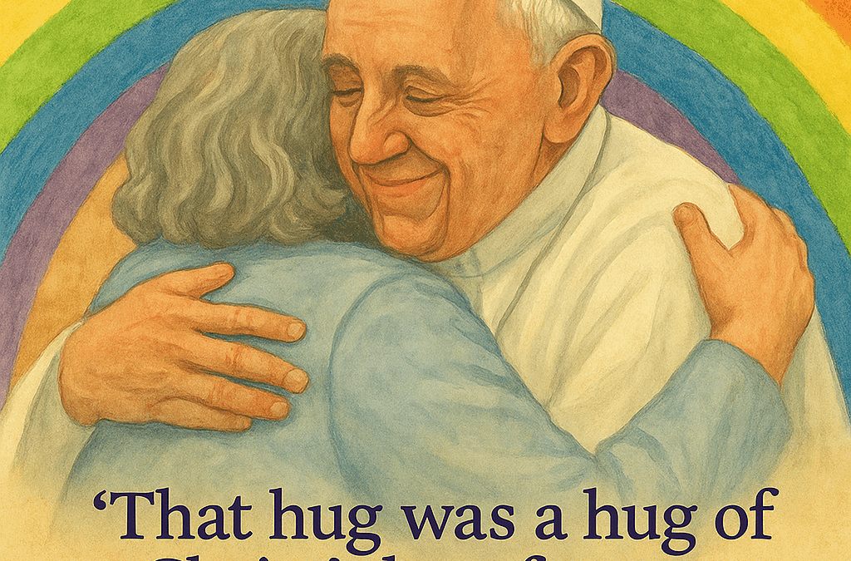

The loss of Pope Francis is felt around the world, with world leaders sending their standard messages of condolence. Faith leaders express their heartfelt sorrow, people of different faiths share their genuine grief, and people of no faith pay their respects through the many social media platforms.

Pope Francis was clearly a man of God who transcended all social, political, and religious boundaries, touching the hearts and souls of all who encountered him—whether across the miles or in person.

I am of an age where the sharp edges of idealism have been smoothed, perhaps even jaded. And yet, how my heart leapt with joy—like a teenager meeting their idol. But this was no idol. This was the wonderful, humble Pope Francis. My years of sleepwalking in faith were stirred to life when I heard Pope Francis call for the smell of the sheep to be brought into the Church. When he described my Church as a field hospital, and a Church for the poor, I knew that this was what Christ would have wanted—if his movement were ever to become an institution.

Pope Francis stirred my heart to stop being a mere pew-blocker and to become an evangelist Christian, to put words and beliefs into action—to put the disenfranchised, the marginalized, the outlier at the centre of Christian love. To have Christ as a model in every aspect of my life.

Meeting Pope Francis stripped me of all pretensions and human foibles. I felt like a child again. I felt the wonder of being in the presence of Christ’s goodness, personified in Pope Francis. I laughed tears of joy when I felt the warm, unconditional love in his embrace. The Pope embraced me! He reached out and embraced me, even though I was a tongue-tied person who could not articulate what I wanted to say. The enormity and joy of that moment will stay with me forever. For it was not a moment just for me—it was a moment that will last forever for all LGBT people around the world.

That I was there, as a member of the Global Network of Rainbow Catholics, to represent all our members across the globe.

That moment of intimacy, that moment of love—that hug—was a hug of Christ’s love from our beloved Pope Francis. We are enveloped in that embrace and cherished within it. I return that hug to Pope Francis a billion-fold, from people all around the world—albeit virtually and spiritually—who simply love Pope Francis as much as he loved us. Thank you for all that you are, and all that you will be. Our hearts are aflame with your love and passion for us. We will continue to do your work. Forever in our hearts.

(April 26, 2025)

[| Global Network of Rainbow Catholics](https://rainbowcatholics.org/sn/19294/)

(A minute of silence)

***Requiem Aeternam*(“Eternal Rest”)**

V. Eternal rest grant unto Francis, O Lord.  
R. And let the perpetual light shine upon him.

And may his soul, and the souls of all the faithful departed,  
through the mercy of God, rest in peace.